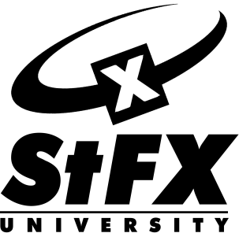
University Math Preparation (Online)

July 22 to August 30, 2013

This non-credit interactive course is intended to prepare students for university level math courses. Some of the main topics studied in this course are mathematical functions, trigonometry, and an introduction to limits.

This online course uses MoodleTM and CollaborateTM (a microphone and speakers or headset is required) and features 12 lessons, video lectures, supplementary materials as well as guidance and feedback from the instructor. This is a great opportunity to prepare for successful participation in university math courses, from the convenience of your home, and with flexibility for your schedule.

The course will cover:
- Linear Functions
- Power Functions
- Quadratic Functions
- Exponential Functions
- Logarithmic and Inverse Functions
- Laws of Logarithms
- Periodic and Sinusoidal Behaviour
- Special Angles, Identities, and Trigonometric Equations
- Inverse Trigonometric Functions and Identities
- Polynomial Functions
- Rational Functions
- Limits

Students wishing to have St. Francis Xavier University recognize this course as satisfying the prerequisite of a pre-calculus course can opt to write an exam (a minimum grade of 70% is required to attain the prerequisite).

Tuition: $373.75 (includes HST)
Registration deadline: July 15, 2013
Instructor: Anthony Grover
For more information contact:
StFX Continuing & Distance Education
(902) 867-3319 or 1-877-867-5561
http://sites.stfx.ca/continuingeducation/

Registration is limited

